“Kritzer created an inner life in his playing of Bach.”
Bernard Holland, The New York Times

s c o t t k r i t z e r
c l a s s i c a l g u i t a r i s t
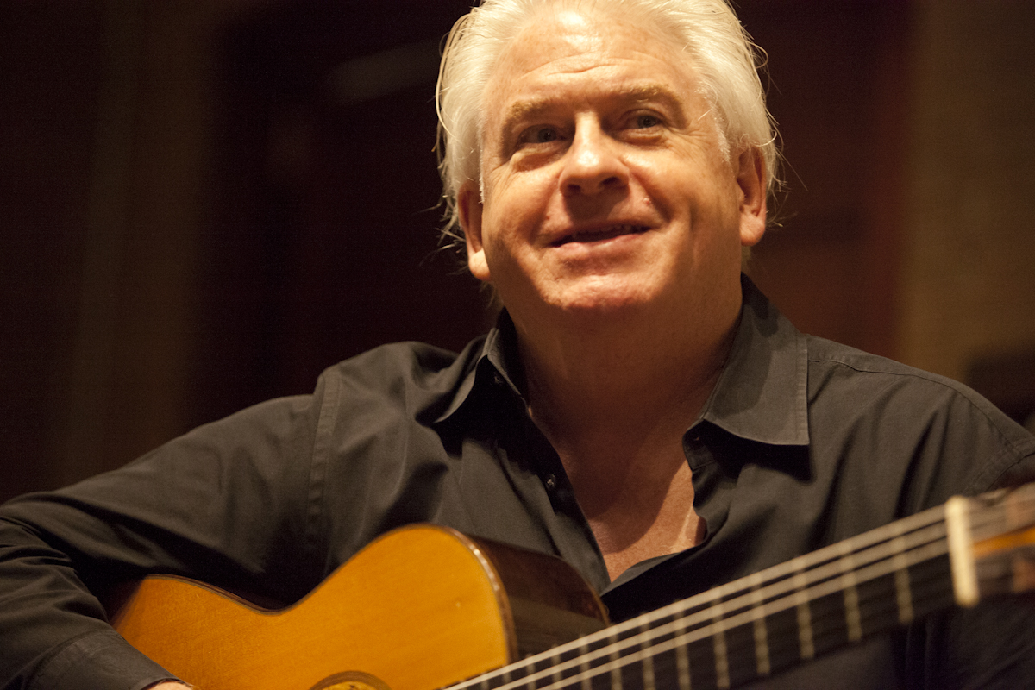

Performing works by JS Bach, William Walton, SL Weiss, J. Froberger, Reginald Smith-Brindle and others

Presenting Organization
Scott Kritzer, Classical Guitar
in concert
Date
Time
Hall Name/Hall Address
Ticket Information

“…a guitarist in the best modern American mold.”
Colin Cooper, Classical Guitar, London

“Kritzer’s inherently lyrical style
extended each line beyond the notes themselves.”
David Stabler, The Oregonian

